Article

A denoising and Fourier Transformation based spectrograms in ECG classification using Convolutional Neural Network

Muhammad Farhan Safdar 1,*, Robert Marek Nowak 2 and Piotr Pałka 3

|  |
| --- |
| **Citation:** To be added by editorial staff during production.  Academic Editor: Firstname Lastname  Received: date  Accepted: date  Published: date  **Publisher’s Note:** MDPI stays neutral with regard to jurisdictional claims in published maps and institutional affiliations.    **Copyright:** © 2022 by the authors. Submitted for possible open access publication under the terms and conditions of the Creative Commons Attribution (CC BY) license (https://creativecommons.org/licenses/by/4.0/). |

1 Faculty of Electronics and Information Technology, Warsaw University of Technology, Poland;

[muhammad_farhan.safdar.dokt@pw.edu.pl](mailto:muhammad_farhan.safdar.dokt@pw.edu.pl), mfarhan166@gmail.com

2 Faculty of Electronics and Information Technology, Warsaw University of Technology, Poland; robert.nowak@pw.edu.pl

3 Faculty of Electronics and Information Technology, Warsaw University of Technology, Poland; [piotr.palka@pw.edu.pl](mailto:piotr.palka@pw.edu.pl)

**\*** Correspondence: Muhammad Farhan Safdar - mfarhan166@gmail.com

**Abstract**

The non-invasive electrocardiogram (ECG) signals are useful in heart condition as-sessment and are found helpful in diagnosing cardiac diseases. However, traditional ways i.e., medical consultation and machine learning models require effort, knowledge, and time to interpret the ECG signals due to large amount of data and complexity. Neural networks have shown to be efficient recently in interpreting the biomedical signals including ECG and EEG. The novelty in proposed work is representation of possible reduced data to convolutional neural network model in well distinguishable form i.e., Spectrograms through Short Time Fourier Transformation (STFT) instead of raw signals. The data reduction performed by frequency filtration by taking a certain cutoff value with which a simple architecture of CNN model showed high accuracy rather than to utilize the complex model which ultimately requires more momeory and computational power. In this study, a diverse approach adopted by acquiring spectrograms using STFT as an input to convolutional neural network model. A large publicly available PTB-XL dataset was utilized, and two datasets were prepared i.e., spectrograms and raw signals for binary classification. Signal denoising, unnecessary frequency filtration and Short Time Fourier Transformation were applied to generate and process the spectrograms. Further, up and down sampling of the signals were performed at various points and accuracies attained. The highest accuracy of 99.06\% achieved by our proposed approach which reflects spectrograms are better than the raw signals. The software, developed in Python, is available freely on http:// https://github.com/mfarhan166/ECG-Signals-and-Spectrograms under MIT license.

**Keywords:** Electrocardiogram; Convolutional Neural Network; Fourier Transformation; Spectrograms;

1. Introduction

Electrocardiogram (ECG) signals are non-stationary, risk free and using them is inexpensive to measure the electrical activity of the heart. The ECG signal consists of waves in the forms of P, Q, R, S, and T notations called one complete cardiac cycle (as shown in below fig. 1), plotted as an X-Y plot where x-axis represent time and voltage on y-axis which shows heart activity. These are used to identify cardiac abnormalities and diseases.  These waves need to be transformed for the classification model to detect heart disease i.e., a noise free wave [1]. The ECG signals consisted of segments (as given in fig.1) which depict the region between two waves i.e., PR and ST. The said regions are important to know the time interval of depolarization and repolarization among heart chambers i.e., atria and ventricles activation and the changes in these segments are useful in heart disease prediction. Similarly, the RR interval and R-peaks are also crucial factors to determine the patient's health status [2]. ECG is useful in finding various heart related diseases including cardiovascular disorder [48], heart bundle branch block [49], ST-T ischemic changes for coronary heart disease [50], atrial fibrillations due to disordered heart rhythm [51], left ventricular hypertrophy [52] and acute pericarditis [53]. Anteroseptal myocardial infarction (ASMI) considered in this study is one of the life-threatening heart diseases that occurs due to the rupture of the volatile atherosclerotic plaque in the left anterior descending artery and can be detected through ECG test [3].

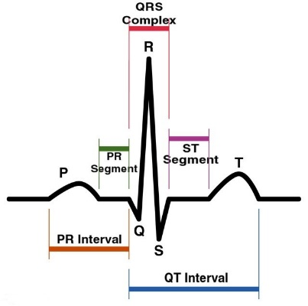

**Fig. 1**: ECG Cardiac Cycle (image credit: Public Domain)

ECG signals have some non-cardiac signals, making them noisy, thus affecting the ability to differentiate between normal and abnormal signals. The noise in the signals produces some additional frequency components i.e., low, and high frequencies. These push the vital clinical evidence beyond and therefore, a misclassification occurs [4-5]. The noise is of diverse types including powerline interference, muscle artifacts, baseline wanders and electrode contact. The impact of noise on ECG is sometimes much worse, corrupting to an extent making the medical professionals impossible to study. The delays due to repeating the ECG or wrong interpretation may be harmful for the patients’ health [4,6]. A signal denoising is a crucial factor for the accurate disease classification from the ECG signals. Wavelet transformation (WT) has become famous in biomedical signals since the 1990s for giving the progressive interpretation of the data. WT extracts the features from signals by decomposing input data into smooth patterns then performs reconstruction of the signals which gives better understanding [7]. WT has two types: continuous and discrete wavelets. The continuous WT follows the shifting and scaling mechanism of the base signal, utilizing each conceivable wavelet, therefore, it is highly redundant. The discrete WT (which applied in this study) on the other hand pursues only the limited set of wavelets such as locations and scales, thus, more efficiently [8]. The types of noises discussed earlier i.e., baseline wanders and powerline interference can be constricted by applying the denoising technique based on discrete wavelet as done in [9-10]. The cleaned signal gives a better interpretation of the ECG. To apply the denoising approach, diverse wavelets from the families including Daubechies, Bior and coif are practiced enhancing the signals [11]. The main reason for preference of WT for signal denoising is that it offers range of wavelets i.e., Daubechies, Haar, Coif, Sym and Bior. Therefore, there are number of options available under single approach to find the best matching wavelet for the presented problem.

Another approach for ECG signals analysis is Fast Fourier Transformation (FFT) which is used to transform the signals into time-frequency domain [12]. Correspondingly, a sliding window-based version of the Fourier transformation called Short Time Fourier Transformation (STFT) deployed in proposed study is used for the efficient signal analysis both in terms of computational time and memory. STFT is comparatively faster and has good precision as highlighted in [46]. The other possible time-frequency transformation methods are Fast Fourier Transformation [45], synchro squeezed transform [46] and Continuous Wavelet Transformation [47]. It takes few parameters to perform transformation i.e., signal data array as time-series, length of the segments, sampling frequency as number of samples per cycle, overlapping points among the segments ratio which usually set as 25%, 50% or 75% and window size [13-14] as described in [15]. By applying the discussed approach, the output appears in the form of a graph called spectrograms which shows the time on x-axis, frequency on y-axis and the color intensity represents the level of amplitude. The studies [16-17] suggest, the signals are more distinguishable in the spectrograms rather than from the raw signals. In the below fig. 2, (a) and (c) are showing the raw signal of NORM and ASMI class respectively, while (b) and (d) represents the transformation of raw signals into spectrograms for both classes. A difference can be seen between NORM and ASMI spectrogram at signal base. There is a spread or light shadow in ASMI spectrogram which is condensed or dark in NORM spectrogram.

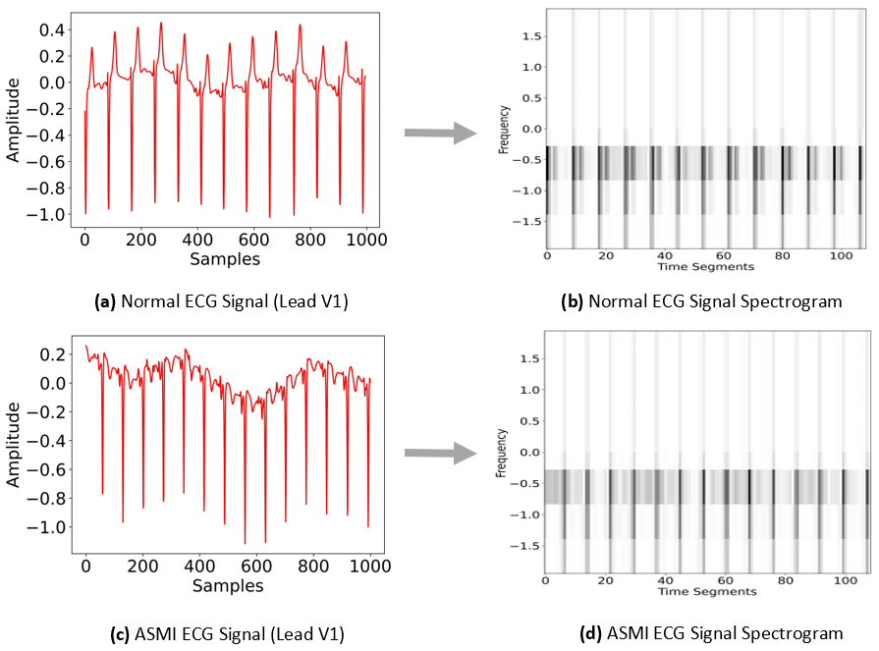

**Fig 2.** Transformation from Raw signals to Spectrograms

Identifying the diseases from the resultant spectrograms is not only difficult for humans but for the traditional models as well. These require narrow observation and/or computation [18]. Therefore, neural networks such as Convolutional Neural Network (CNN) are considered as one of the exceptional classification models. CNN takes images as an input, extract the features, and produces the classification result with more accuracy even in shorter time [19-20]. In recent years, it has been widely deployed for the various classification problems by the different researchers [20],[27], [31-32]. CNN models proposed by [21], [38-40] used spectrograms as input to predict heart disease. In the existing ECG signal analysis, the images to classification model consumes more memory and computation because of the high dimensions. Therefore, the study aimed to decrease the data size without losing the vital information and affecting the accuracy.

In the proposed study, the size of ECG images is reduced through denoising, unwanted frequencies filtration and generating the spectrograms by applying the STFT transformation. With this approach, comparable accuracy at a smaller number of parameters is achieved. Further, up and down sampling rate of ECG signal was performed and evaluated the classification model on it. The novelty of proposed work is representation of data to convolutional neural network model in well-defined form i.e., Spectrograms. Additionally, data size reduction aim is achieved through frequency filtration at which a simple architecture of CNN model showed high accuracy rather than to utilize the complex model which ultimately requires more memory and computational power.

In section II, related work over various filters for signal denoising, neural networks in imaging, and spectrograms in ECG signals analysis using CNN is presented. In section III, overall methodology consisting of pre-processing techniques, dataset preparation, model architecture is described. In section IV, experiments, and their results along with discussion are presented. In section V, a conclusion of study is given.

2. Related Work

Several approaches have been adopted by the researchers to remove the noise from the signals i.e., authors of [22-23] applied WT and Savitsky Golay filter, which is a signal smoothing approach. Authors in [22] additionally considered other techniques including lowpass filter, moving average filter, gaussian and median filter for the comparative analysis. M. Gusev et al. [24] applied and compared the Finite Impulse response (FIR) filter, infinite impulse response (IIR) filter and DWT to detect the QRS peak from the signals. Study results showed that they achieved 98.2% QRS detection accuracy over the MIT-BIH Arrhythmia dataset with DWT. Likewise, Generative Adversarial Network (GAN) and Residual Network were used by Bingxin Xu et al. [25] to clean the ECG signals. They found GAN as an efficient method compared to WT, S-Transform algorithm and stacked denoising autoencoder in terms of better signal to noise (SNR) ratio. Similarly, Kan Luo et al. [26] applied the basis pursuit denoising (BPDN), low pass filter and alternating direction method of multipliers algorithm to remove the noise over MIT-BIH Arrhythmia dataset. Higher SNR and lowest mean squared error (MSE) have been achieved by their implemented methods.

Neural networks are becoming essential for classification tasks and outperform other classification techniques. Authors of [27-29] applied CNN based architecture models on X-Ray imaging dataset for the classification of COVID-19 pneumonia and found the highest accuracies as 99.5%, 98.3% and 94.5% respectively. Cardiac Vascular is a non-invasive imaging test which is handy for the identification of narrowing arteries of the human heart. Ilyass Abousaleh et al. [30] performed a binary classification on the BraTS 2017 dataset using CNN architecture to classify the low- and high-grade glioma from normal images. The uppermost accuracy was achieved as 91% on the binary class problem. Likewise, Marcin Wozniak et al. [31] choose a hybrid approach of CNN and classic Artificial Neural Network (ANN) model which help the CNN to select the better filters for convolutional and pooling layers and for the classification of brain tumor from Computed Tomography (CT) scans. The highest accuracy of 98%, has been attained by their proposed approach with 95% precision and recall. Litjens Geert et al. [32] conducted a survey of more than 80 papers, presented on cardiac vascular images and neural networks. Most of the researchers utilized CT, magnetic resonance imaging and ultrasound images as datasets. CNN based architectures, RNN (Recurrent Neural Network), LSTM (Long Short-Term Memory) and GAN were applied for the classification purpose. Conclusively, the neural networks are useful for the disease classification and even few outperform models are under consideration by the Food and Drug Administration (FDA) for real clinical practice as mentioned by [32]. However, further improvements can result in more achievements.

Siti Nurmaini et al. [33] evaluated RNN based bi-directional LSTM model for the classification of ECG on binary problems. They utilized the QT database and Lead-II of the Lobachevsky University Database for training and evaluation of the proposed model. Firstly, noise has been removed through discrete WT by applying bior6.8 wavelet, a signal filtration approach, then they performed the segmentation. Study results revealed 99.64% accuracy with 98.81% precision has been achieved. Yan Fang et al. [34] analyzed the ECG signals using the radial basis function (RBF) neural network on the MIT-BIH dataset. Initially, they removed the noise by practicing high pass (11 Hz cutoff) and low pass filters. After that they extracted the QRS segment features using Pan Tompkins algorithm which is a QRS complex detector [35], and then authors applied k-means clustering for the sample screening purpose. Finally, they trained the neural network on a given dataset and achieved 98.9% classification accuracy. Dinesh Kumar Atal et al. [36] observed the ECG arrhythmia classification using Bat Optimization Algorithm [37] based on deep CNN (BaROA-DCNN) over MIT-BIH dataset. Like the authors [33], they applied the WT for removal of noise and then a Gabor filter was exercised to extract the features. The BaROA-DCNN model has been trained on given dataset examples along with the other models including knowledge-based model, Support Vector Machine (SVM), classical CNN, Genetic Algorithm-Back Propagation Neural Network (GA-BPNN), CNN+LSTM separately. The highest accuracy revealed by their projected BaROA-DCNN model was 93.19% while the lowest was 85.07% by the knowledge-based model.

In this study, a more diverse approach is proposed than the above presented by applying denoising, cut-off frequencies and STFT transformation to spectrograms with CNN model. A similar study by Jingshan Huang et al. [38] classified ECG arrhythmias by applying Fourier transformation named as STFT and input the spectrograms to the CNN model. Five distinct types of heartbeats data including normal were extracted from MIT-BIH arrhythmia dataset. Authors followed the comparable way as adopted in proposed study except for the produced spectrograms image sizes which were 256x256 dimensional spectrograms with batch size of 2500. Study results revealed that 99% accuracy has been achieved by their approach. A similar but eight class problems classification has been done by Amin Ullah et al. [39] by feeding spectrograms into CNN model. Initially, they removed the noise from ECG signals using wavelet transformation and then applied Data Augmentation (DA), a cropping technique, to deal with the class imbalance. They produced the spectrograms by STFT transformation and resized the images to 256x256 dimensions for the final input to CNN model. Study results showed 99.11% accuracy with 98.59% precision. Their technique follows the same way as trailed in this work, however, current study images size, number of parameters and batch size are lower, yet achieving comparable accuracy.

Guo Yang Liu et al. [40] assessed the ECG quality by applying the Stockwell-Transform (S-Transform) and generating the spectrograms as an input to CNN model. The relevant dataset was acquired from Physio net CINC challenge of 2011. They applied the Butterworth filter with the frequency cutoff 0.1 to remove the noise from the signals. The online augmented scheme along with S-Transform has been applied on the ECG signals for the purpose of better time frequency depiction. Various approaches including statistical features, CNN and augmented S-Transform were applied separately and within the combination. Study results showed that the highest accuracy achieved was 93.01% when the mentioned approaches i.e., AugS-Transform with CNN + Statistical Features, were applied on the given dataset.  The summary of the literature review is given in Table 1 below.

**Table 1:** Summary of the Literature Review

|  |  |  |  |  |
| --- | --- | --- | --- | --- |
| **Authors** | **Pre-Processing Approaches** | **Dataset** | **Model** | **Performance (Accuracy)** |
| Mishra A. et al. [22] | DWT, Savitsky Golay filter, Butterworth filter, Moving Average, Gaussian Filter, Median Filter | MIT-BIH Arrhythmia Database | Custom Convolutional Neural Networks | 93% |
| Marjan Gusev et al. [24] | FIR, IIR, DWT | MIT-BIH Arrhythmia database | - | 98.20% |
| Bingxin Xu et al. [25] | GAN | MIT-BIH Database | Residual Network (ResNet) | 40.8526 dB (SNR)  0.0102(RMSE) |
| Ruixia Liu et al. [26] | BPDN, Low pass Filter, BP-ADMM | MIT-BIH ECG database | - | 16.02 dB (SNR)  0.002 (MSE) |
| Siti Nurmaini et al. [33] | DWT, low/high pass filters, segmentation | QT database, Lead-II The Lobachevsky University Database | Bi-directional LSTM | 99.79% |
| Yan Fang et al. [34] | low/high pass filters | MIT-BIH database | RBF neural network | 98.9% |
| Dinesh Kumar Atal et al. [36] | DWT, Gabor filter | MIT-BIH Arrhythmia database | Bat optimization based Deep CNN | 93.19% |
| Jingshan Huang et al. [38] | STFT Transformation | MIT-BIH Arrhythmia database | 2D-deep CNN | 99% |
| Amin Ullah et al. [39] | DWT, Data Augmentation, STFT Transformation | MIT-BIH Arrhythmia database | CNN | 99.11% |
| Guo Yang Liu et al. [40] | Butterworth filter, Stockwell Transform spectrograms, online augmentation | Physio net CINC challenge of 2011 | CNN | 93.09% |

3. Methodology

The ECG signals may contain various type of noises i.e., baseline wander, power line interference which produces some additional frequency components i.e., low, and high frequencies and can affect the classification accuracy. Therefore, wavelet transformation was considered for denoising the signals. Similarly, Fourier Transformation divides the biomedical signals into time-frequency domain, through which an unwanted frequency can be filtered with the purpose of data size reduction. The key advantage of reducing data size is to present the complete data into less resolution image i.e., spectrogram which helps in memory and computational management. Spectrograms depicts the data into more distinguishable form than the raw signals i.e., recent studies [38-40] reveals that the data feed as spectrograms into neural network resulted in better accuracy which urged us to produce spectrograms using STFT.

Initially, the 12-leads ECG PTB-XL dataset was downloaded from the well-known repository physionet.org [41]. The dataset consisted of 21,837 records of 18,885 patients recorded at 100 Hz sampling rate over 10 seconds in length. The current study methodology into three parts. Firstly, pre-processing on the given data was applied and spectrograms were generated. Following this, datasets were prepared and finally, CNN model for classification purposes was applied. The details are given below:

3.1. Pre-Processing

3.1.1. Denoising

The given signal data had some noise on the baseline which affects the overall accuracy, therefore, it is necessary to clean it. Wavelet transformation was choosen to remove the noise from the signals as shown in Algorithm 1.

|  |
| --- |
| **Algorithm 1:** Denoising |
| Step 1: $L_{coeff}=dwt(data,wavelet,mode)$ Step 2: $V_{sigma}= \left[\left(1/{0.6745}\right)×M_{a. dev}(L_{coeff})\right]$ Step 3: $V_{thresh}= V_{sigma} ×\sqrt{( 2×log (len\left(data\right) )}$ Step 4: $F_{coeff}$ = $∀ x_{i}∈L_{coeff}, \left\{ i=0, 1,2…n \right\}$ $thresh(x_{i},V_{thresh},mode)$ Step 5: $R_{sig}$ = $Inverse_dwt (F_{coeff},wavelet,mode)$ |

In algorithm 1, initially, the list of coefficients was calculated ($L_{coeff}$) using discrete wavelet transformation (dwt) from pyWT python library [42]. The function dwt takes three parameters including signal data, wavelet as bior3.1 (as proposed work results are better at this wavelet) and the mode as periodic. The results of dwt are stored in $L_{coeff}$. Now, the sigma value ($V_{sigma}$) was considered to find the threshold by measuring the mean absolute deviation ($M_{a. dev}$) of the $L_{coeff}$. The constant value of 0.6745 set as given at [43] which depict the ratio of standard deviation to ($M_{a. dev}$) and is a robust value of noise coefficient amplitude [44]. In the next step, the threshold value ($V_{thresh}$) was computed by multiplying the $V_{sigma}$ with the log of a given data length. At step 4, $V_{thresh}$ was applied to keep only those coefficients ($F_{coeff}$) which have greater value than the $V_{thresh}$ to remove the unwanted coefficients from the list. The thresh function was utilized from the pyWT library [42] which needed three arguments including each index of the coefficient list (found at step 1), threshold value (find at step 3) and mode as periodic. Finally, the inverse dwt was applied to retrieve the signal and stored it in resultant signal ($R_{sig}$). The inverse dwt function [42] takes the following variables as input: filtered coefficient list as $F_{coeff}$, wavelet and the mode. The $R_{sig}$ is then stored into a NumPy file for further frequency filtration.

3.1.2. Frequency Filtration

Frew frequencies were filtered to reduce data to the next level after performing the denoising approach. The study is based on the ASMI disease classification which only focuses on the baseline signals, therefore, data which presents peak-level signals was deleted i.e., R-peaks. The various cutoff frequencies were manually tested, and value two (2) found as the best cutoff. At this cutoff value, vital information retained by achieving success in data reduction aim.

|  |
| --- |
| **Algorithm 2:** Frequency Filtration |
| Step 1: $x= load_data (signal)$ Step 2: $x_{t}= fourier_transformation (x)$ Step 3: $∀ x_{i}∈x_{t}, \{ i=0, 1,2…n \}$ $$S_{freq}= fourier_trans_freq. \left(x_{i}\right) \\ x_{clean}=del (x_{i}, S_{freq}>2)$$ Step 4: $F_{sig}=Inverse_fourier_transform (x_{clean})$ |

As shown in algorithm 2, firstly, denoised signals data were loaded from NumPy files which were stored during the denoising process (output of algorithm 1). Next, FFT was computed on the given time series data and stored it into variable $x_{t}$. In step 3, sampling frequency ($S_{freq}$) of each signal (stored in variable $x_{i}$ from $x_{t}$) was calculated using the SciPy Fourier transformation frequency function. At the same time, a frequency cutoff value on the signal $x_{i}$ was applied to delete the unwanted frequencies along with the data and store the results in variable $x_{clean}$. Finally, inverse Fourier transformation was used to retrieve the $x_{clean}$ reduced signal data and stored it in variable $F_{sig}$. The data in $F_{sig}$ was further stored in a NumPy file to generate the spectrograms. In the below Fig. 3, (a) is showing spectrogram before frequency filtration in which X-axis represents time segments and Y-axis represents frequency while (b) is showing after operation with the same axis information. One can see the frequency, time segments and black shadow reduced in fig. 3 (b) after performing frequency filtration operation.

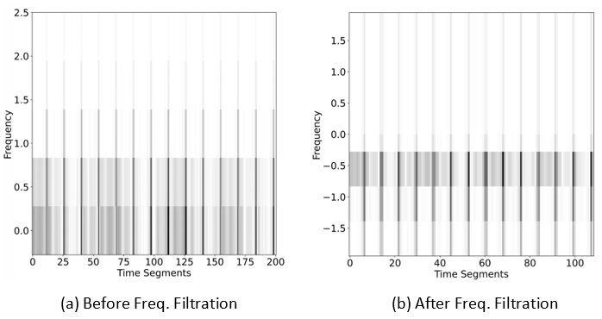

**Fig. 3:** Spectrogram before and after frequency filtration

3.1.3. Spectrograms

The spectrograms give a more distinguishable shape of the signals than the raw signals [16-17]. Therefore, spectrograms were produced after performing the denoising and frequency filtration procedures. SciPy signal library was utilized to import the STFT based transformation for the spectrograms. The STFT takes a few arguments (as discussed in the introduction section) to generate the spectrograms. Several parameter values were tested and found few suitable by manual visualization where spectrograms give better interpretation and are more distinct. Thus, the number of FFTs (NFFT) and segments were set to 9, over looping length to half of the NFFT and sampling frequency to100 Hz at which signals were computed by the machine. The dimensions of the spectrograms were set to 64x64 with the gray scale color map and stored in the form of portable network graphics (.PNG) images.

3.2. Dataset Preparation

The PTB-XL signal were originally calculated at sampling rate of 100 Hz and 500 Hz. However, 100 Hz sampling rate was chosen in which each signal measured for 10 seconds of the length. The dataset consisted of 44 classes, out of which only a few had a higher number of samples. There was a class imbalance among the dataset classes. The whole dataset divided into two parts ASMI and normal (NORM) according to proposed work. ECG consists of 12-leads (I, II, III, aVR, aVL, aVF, v1-v6), only v1 lead data is acquired in the dataset preparation. Only those samples were inserted in the ASMI class which originally belonged to this and the rest of all the images were moved to the NORM class. Since the class imbalance occurs for the ASMI, therefore, two data augmentation approaches were applied i.e., horizontal flip and image contrast enhancement. However, it has been carefully considered to use only data augmentation approaches which have no effect or have possible minimum on original data. Some images were also duplicated to deal with the ASMI class imbalance problem

3.3. Model Architecture

As discussed earlier, CNN model is one of the popular classification models over image data. Therefore, the said model is chosen for current study to perform classification over the prepared dataset. The projected architecture is given in Fig 4.

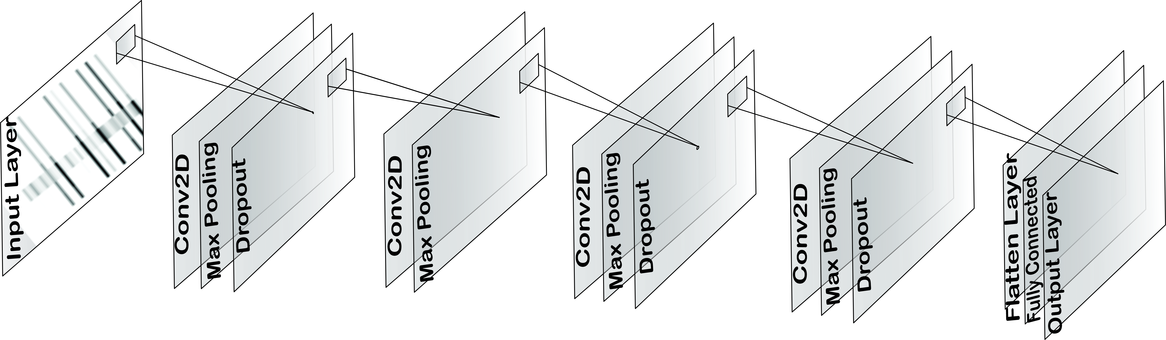

**Fig. 4:** Proposed Model Architecture

In the proposed 2-dimensional CNN model, four convolutional layers were applied. The input layer accepts a 64x64 dimension image as a spectrogram. The first layer has 64 filters (3x3) in size along with 2D Max Pooling (2x2) in size and 0.25 dropout to avoid overfitting. In the second layer, the filter size increased to 128 with a size of 3x3 and 2D Max Pooling (2x2) was added. The third layer was formed with an increased 256 filters (3x3), 2D Max Pooling (2x2) and 0.25 dropout. The fourth layer consisted of 64 filters (3x3), 2D Max Pooling (2x2) and 0.25 dropout. The biases and rectifier linear unit (ReLu) activation function were added in each layer. Next, the flatten layer comes up and then a fully connected dense layer with 8 filters size appears. Lastly, one denser layer as an output layer structured with 1 filter size, sigmoid activation function and L1 type of activity regularizer. The total number of parameters in this model are 0.52 million. In the model compilation, binary cross entropy loss with learning rate 0.001 and Adam optimizer was set. The given architecture is chosen by taking six number of layers randomly at start and attempted model training with different hyperparameters. However, the accuracy was not good as it is. Therefore, number of layers were reduced and re-tune the hyperparameters. The best accuracy achieved at four layers and with the mentioned hyperparameters i.e., as given above.

4. Experimental Setting and Results

A Jupyter notebook over google research Colab with Tesla T4 GPU, 15.10 GB GPU memory and 12.68 GB CPU RAM was set up to perform the experiments. Python as a programming language with several libraries was used. The details of the implementation are as follows:

4.4.1. Memory Consumption

Keeping in view of the data size reduction aim, firstly, two datasets i.e., spectrograms (as discussed in the pre-processing phase) and raw signals were created. The raw signal dataset was generated only with the denoising approach. However, the number of images (39, 908), dimensions (64x64) and forecolor as grayscale were the same for both datasets.

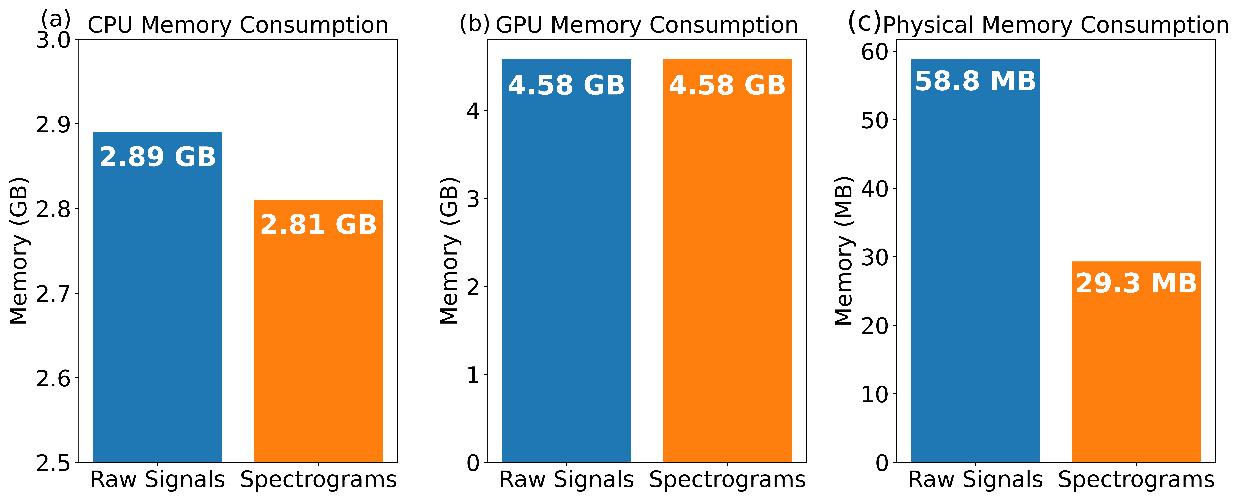

**Fig. 5:** Memory Proportion

Fig. 5 shows that the proposed spectrograms consume less CPU memory compare to the raw signals dataset in (a), while for the GPU memory, memory consumption ratio is same for both datasets in (b). However, around 50% less physical memory consumption can be seen for the spectrograms compared to the raw signals with equivalent properties in (c). The said difference is because we reduced the samples in spectrograms by applying frequency filtration. The spectrogram dataset holds physical memory size of 29.3 MB while the raw signals are of 58.8 MB data size.

4.4.2. Model Evaluation

CNN model was trained and evaluated on both datasets including spectrograms and raw signals separately. The hyperparameters were tuned as per the requirements. Batch size was set to 256 for both training & validation along with 500 epochs and 10 steps per epoch. It is pertinent to mention here that the exact model architecture (as described earlier) and hyperparameters were utilized for both datasets.



**Fig. 6:** Data Analytics and Validation Accuracy

Fig 6 shows the overall performance and validation accuracy for the two datasets. The accuracy, precision and loss on spectrograms dataset were 99.06%, 100% and 0.04 respectively, all in log scale. One can see, accuracy, precision and loss are better than raw signals' dataset as represented in blue bars. Similarly, at the right-hand line graph, the validation accuracy is given at different epochs for both datasets. The improved convergence curve can be seen for the spectrogram’s dataset at each next epochs i.e., top accuracy as 99.06% at 500 epochs. The accuracy on raw signals dataset goes into the 70's at 100 epochs but then did not improve at all.

4.4.3. Learning Rate

The CNN model achieved 99% accuracy on spectrograms dataset, therefore, we decided to further evaluate the various learning rates. An increment and decrement in the learning rate from 0.001 was considered, the point at which highest performance was obtained. Various learning rates such as 0.1, 0.01, 0.001, 0.0001 and 0.00001 were considered here, rest of all other hyperparameters and model architecture kept the same as it was previously.



**Fig. 7:** Learning Rate Evaluation

Fig. 7 shows the accuracy of both datasets at various learning rates. The optimal learning rate found was found as 0.001 for both datasets, beyond this limit i.e., at 0.1 and 0.01, the accuracy fell below than 60% which is the least. Similarly, when goes beyond the optimal learning rate i.e., 0.001, the accuracy again showed dropping trend.

4.4.4. Sampling Rate

The well-known wfdb-python package was utilized to perform up and down sampling. Initially, the signals were sampled at 100 Hz which means 100 samples in a cycle or one second. Signals were recalculated at a distinct sampling rate i.e., 25, 200, 600, 1000 to evaluate the accuracy at various rates. The same model architecture and dataset (spectrograms) were utilized for all the sampling rate experiments.



**Fig. 8:** ECG Sampling Rate

In Fig. 8, a fluctuation among the various sampling rates can be seen. Adding or deleting dummy data among the original signals cannot achieve the performance equal to the original signals. However, it was observed that the amplitude is dropped at each next up sampling rate. An acceptable accuracy of 85.78% was achieved at 50 Hz sampling rate. Likewise, at 400 Hz and 800 Hz i.e., more than 80% accuracies are achieved, whereas the rest of all the sampling rates depict less accuracies. With this experiment, our preposition was to increase and decrease the sampling rate gradually w.r.t. actual learning rate with the purpose to test whether any possibility to achieve equivalent accuracy compare to original sampling rate.

4.4.5. Comparison with Existing Methods

The proposed approach is compared with present methodologies in terms of performance and the classification model. To prevent the unfairness, only those studies were selected which have quite similar implementation approaches as current work. Firstly, proposed approach is compared with studies that implemented a parallel classification model over ECG signals but did not consider the spectrograms. Mishra Abhinav et al. [22] applied Custom CNN to predict the arrhythmia on denoised signals using MIT-BIH Arrhythmia Database. Their suggested approach achieved 93% accuracy, which is lower than proposed work results. Similarly, Dinesh Kumar et al. [36] also applied optimization based deep CNN model to identify the ECG signals for arrhythmia. They obtained 93.19% accuracy by their proposed work as shown in table 2. Both authors exercised signal denoising approaches, which considered in this work and are obligatory to filter the noise. However, spectrogram was found as a necessary part by this study for better classification.

**Table 2:** Assessment with Similar Classification Model

|  |  |  |
| --- | --- | --- |
| **Authors** | **Model** | **Accuracy** |
| Mishra A. et al. [22] | Custom Convolutional Neural Network | 93% |
| Dinesh Kumar Atal et al. [36] | Bat optimization based Deep CNN | 93.19% |
| **Proposed Work** | **CNN (with spectrograms)** | **99.06%** |

Keeping in view of the above, proposed work compared with the authors who followed the spectrograms approach before performing the model training. Studies by [38-40] applied the transformation (Fourier) to generate the spectrograms as present in proposed work. Table 3. shows the comparison of proposed work with the others.

**Table 3:** Comparison with Spectrogram Approach

|  |  |  |  |  |  |
| --- | --- | --- | --- | --- | --- |
| **Authors** | **Model** | **Accuracy** | **Sensitivity** | **Specificity** | **Precision** |
| Jingshan Huang et al. [38] | 2D-deep CNN | 99% | - | - | - |
| Amin Ullah et al. [39] | Convolutional Neural Network | 99.11% | 97.91% | 99.61% | 98.5% |
| Guo Yang Liu et al. [40] | Convolutional Neural Network | 93.09% | 97.67% | 77.33% | 93.67% |
| **Proposed Work** | **Convolutional Neural Network** | **99.06%** | **99.83%** | **100%** | **99.50%** |

Jingshan Huang et al. [38] and Amin Ullah et al. [39] achieved 99% accuracy while Guo Yang Liu et al. [40] obtained 93.09% accuracy using spectrograms and CNN model. The results by [40] are somehow lower because of the less optimized statistical features and CNN architecture as mentioned by them. As shown, a comparable accuracy of 99.06% achieved in proposed work by applying the transformation. Moreover, the unwanted frequency filtration was also applied along with denoising for further data size reduction as discussed earlier. The high accuracy results show that classification models such as CNN learn and perform well on the spectrograms by extracting better features than the raw signals.

5. Conclusion

In this study, an accurate and diverse approach is proposed for the ECG signals classification. The PTB-XL ECG signals dataset in current study experiments was obtained from physionet.org, a well-established medical signals platform. The novelty in proposed work is representation of possible reduced ECG signals data by highlighting certain cutoff value to convolutional neural network model in well distinguishable form i.e., Spectrograms through Short Time Fourier Transformation (STFT) instead of raw signals. Firstly, a denoising method using WT (bior3.1 wavelet) was applied, and then the frequency filtration was implemented to remove the unnecessary signals without losing useful information. On the resulting data, STFT transformation was applied to generate the spectrograms with grayscale color scheme which also reduced the dataset size. On the other hand, one more dataset of raw signals was prepared by applying the similar denoising approach only. CNN classification model on both datasets was implemented separately using the same architecture and hyperparameters. The proposed approach achieved higher accuracy of 99.06% than the raw signals. Additionally, CNN model was evaluated by performing up and down sampling of the ECG signals sample rate which depicts the fluctuating accuracies. In the future, multi-class problem will be considered from the similar area i.e., ECG signals and will emphasize on class imbalance problem and computational overhead using neural networks.

**Supplementary Materials:** The software, developed in Python, is available freely on [http:// https://github.com/mfarhan166/ECG-Signals-and-Spectrograms](http://xxxx/) under MIT license.

**Author Contributions:** Conceptualization, M.F., R.N. and P.P.; methodology, M.F., R.N. and P.P.; software, M.F.; validation, M.F., R.N. and P.P.; formal analysis, M.F., R.N. and P.P.; data curation, M.F.; writing—original draft preparation, M.F.; Review, R.N. and P.P.; supervision, R.N. and P.P.;

**Funding:** This research received no external funding.

**Institutional Review Board Statement:** Not Applicable

**Informed Consent Statement:** The data used in this study was acquired from publicly available repository and as per policy, anyone can access the dataset.

**Data Availability Statement:** Not Applicable

**Acknowledgments:** Not Applicable

**Conflicts of Interest:** The authors declare no conflict of interest.

References

1. Aziz S, Ahmed S, Alouini M-S. ECG-based machine-learning algorithms for heartbeat classification. *Scientific Reports*. **2021**;*11(1).*
2. Raeiatibanadkooki M, Quachani S, Khalilzade M, Bahaadinbeigy K. Real Time Processing and Transferring ECG Signal by a Mobile Phone. *Acta Informatica Medica*. **2014**;22(6):389.
3. Bhattarai S, Chhabra L, Hashmi MF, et al. Anteroseptal Myocardial Infarction. In: StatPearls. Treasure Island (FL): StatPearls Publishing; 2022-. Available from: <https://www.ncbi.nlm.nih.gov/books/NBK540996/> Accessed on: 20th July **2022**
4. Gupta V, Mittal M. A Comparison of ECG Signal Pre-processing Using FrFT, FrWT and IPCA for Improved Analysis. *IRBM*. **2019**;*40(3):*145–56.
5. Gupta V, Mittal M, Mittal V. Performance Evaluation of Various Pre-Processing Techniques for R-Peak Detection in ECG Signal. *IETE Journal of Research*. **2020**;1–16.
6. Mortezaee M, Mortezaie Z, Abolghasemi V. An Improved SSA-Based Technique for EMG Removal from ECG. *IRBM*. **2019**;*40(1)*:62–8.
7. Amani Al-Ghraibah, Sameh El-Sharo, Jamal Al-Nabulsi, Mustafa Muhammad Matalgah. “Evaluation of the carotid artery using wavelet-based analysis of the pulse wave signal”. *Int J Elec & Comp Eng*. **2022**;*12(2):*1456-1467.
8. Stokfiszewski, K., Wieloch, K. & Yatsymirskyy, M. An efficient implementation of one-dimensional discrete wavelet transforms algorithms for GPU architectures. *J Supercomput*. **2022**; *78*:11539–11563 <https://doi.org/10.1007/s11227-022-04331-8>
9. Samann, Fars and Schanze, Thomas. "An efficient ECG Denoising method using Discrete Wavelet with Savitzky-Golay filter" *Current Directions in Biomedical Engineering*. **2019**; 5(1): 385-387. <https://doi.org/10.1515/cdbme-2019-0097>
10. Gualsaquí, Marco et al. “ECG signal denoising using discrete wavelet transform: A comparative analysis of threshold values and functions.” *MASKANA*. **2018**; *9(1)*: 105-114
11. Ç. P. Dautov and M. S. Özerdem, "Wavelet transform and signal denoising using Wavelet method," *2018 26th Signal Processing and Communications Applications Conference (SIU)*, **2018**; pp. 1-4, doi: 10.1109/SIU.2018.8404418.
12. Zhang, R., et al.: Time-frequency synchroextracting transform. *IET Signal Process*. **2022**; *16( 2)*:117–131. <https://doi.org/10.1049/sil2.12073>
13. Jeon H, Jung Y, Lee S, Jung Y. Area-Efficient Short-Time Fourier Transform Processor for Time–Frequency Analysis of Non-Stationary Signals. Applied Sciences. **2020**; *10(20)*:7208. <https://doi.org/10.3390/app10207208>
14. Carlos Mateo, Juan Antonio Talavera. Short-Time Fourier Transform with the Window Size Fixed in the Frequency Domain (STFT-FD): Implementation. *SoftwareX*. **2018**; 8: 5-8. <https://doi.org/10.1016/j.softx.2017.11.005>
15. STFT Signal — SciPy v1.8.1 Manual. Available from: <https://docs.scipy.org/doc/scipy/reference/generated/scipy.signal.stft.html> Accessed on: 20th July **2022**.
16. Ye F, Yang J. A Deep Neural Network Model for Speaker Identification. Applied Sciences. **2021**;*11(8)*:3603. <https://doi.org/10.3390/app11083603>
17. Weihao Li, Keren Wang, Ling You, "A Deep Convolutional Network for Multitype Signal Detection and Classification in Spectrogram", *Mathematical Problems in Engineering*. **2020**; *vol. 2020*, Article ID 9797302.  <https://doi.org/10.1155/2020/9797302>
18. Jia Li, Yujuan Si, Tao Xu, Saibiao Jiang, "Deep Convolutional Neural Network Based ECG Classification System Using Information Fusion and One-Hot Encoding Techniques", *Mathematical Problems in Engineering*. **2018**; *vol. 2018*, Article ID 7354081. <https://doi.org/10.1155/2018/7354081>
19. Yadav, S.S., Jadhav, S.M. Deep convolutional neural network based medical image classification for disease diagnosis. *J Big Data*. **2019**; *6(13)*. <https://doi.org/10.1186/s40537-019-0276-2>
20. Chiang CH, Weng CL, Chiu HW. Automatic classification of medical image modality and anatomical location using convolutional neural network. *PLoS One*. **2021**;*16(6)*:e0253205. <https://doi:10.1371/journal.pone.0253205>
21. Król-Józaga B. Atrial fibrillation detection using convolutional neural networks on 2-dimensional representation of ECG signal. *Biomedical Signal Processing and Control*. **2022**; *Vol. 74*:103470. <https://doi.org/10.1016/j.bspc.2021.103470>
22. Mishra A, Dharahas G, Gite S, Kotecha K, Koundal D, Zaguia A, et al. ECG Data Analysis with Denoising Approach and Customized CNNs. *Sensors*. **2022**;*22(5)*:1928.
23. AlMahamdy M, Riley HB. Performance Study of Different Denoising Methods for ECG Signals. *Procedia Computer Science*. **2014**; *37*:325–32.
24. M. Gusev and E. Domazet, "Optimal DSP bandpass filtering for QRS detection," 2018 *41st International Convention on Information and Communication Technology, Electronics and Microelectronics (MIPRO),* **2018**, pp. 0303-0308, doi: 10.23919/MIPRO.2018.8400058.
25. Xu B, Liu R, Shu M, Shang X, Wang Y. An ECG Denoising Method Based on the Generative Adversarial Residual Network. *Computational and Mathematical Methods in Medicine*. **2021**(1):1-23
26. Liu R, Shu M, Chen C. ECG Signal Denoising and Reconstruction Based on Basis Pursuit. *Applied Sciences*. **2021**;*11(4):*1591.
27. Aijaz Ahmad Reshi, Furqan Rustam, Arif Mehmood, Abdulaziz Alhossan, Ziyad Alrabiah, Ajaz Ahmad, Hessa Alsuwailem, Gyu Sang Choi, "An Efficient CNN Model for COVID-19 Disease Detection Based on X-Ray Image Classification", *Complexity*, **2021**; *vol. 2021*:1-12
28. Giełczyk A, Marciniak A, Tarczewska M, Lutowski Z. Pre-processing methods in chest X-ray image classification. *PloS one*. **2022**;*17(4):* e0265949
29. Heidari M, Mirniaharikandehei S, Khuzani AZ, Danala G, Qiu Y, Zheng B. Improving the performance of CNN to predict the likelihood of COVID-19 using chest X-ray images with pre-processing algorithms. *International Journal of Medical Informatics*. **2020**; *144*:104284.
30. Aboussaleh I, Riffi J, Mahraz AM, Tairi H. Brain Tumor Segmentation Based on Deep Learning’s Feature Representation. *Journal of Imaging*. **2021**;*7(12)*:269.
31. Woźniak, M., Siłka, J. & Wieczorek, M. Deep neural network correlation learning mechanism for CT brain tumor detection. *Neural Comput & Applic* **(2021)**. <https://doi.org/10.1007/s00521-021-05841-x>
32. Litjens G, Ciompi F, Wolterink JM, de Vos BD, Leiner T, Teuwen J, et al. State-of-the-Art Deep Learning in Cardiovascular Image Analysis. *JACC: Cardiovascular Imaging*. **2019**;*12(8)*:1549–65.
33. Nurmaini S, Tondas AE, Darmawahyuni A, Rachmatullah MN, Effendi J, Firdaus F, et al. Electrocardiogram signal classification for automated delineation using bidirectional long short-term memory. *Informatics in Medicine Unlocked*. **2021**; *22*:100507.
34. Fang Y, Shi J, Huang Y, Zeng T, Ye Y, Su L, et al. Electrocardiogram Signal Classification in the Diagnosis of Heart Disease Based on RBF Neural Network. *Computational and Mathematical Methods in Medicine*. **2022**; *2022(9)*:1-9
35. Fariha MAZ, Ikeura R, Hayakawa S, Tsutsumi S. Analysis of Pan-Tompkins Algorithm Performance with Noisy ECG Signals. *Journal of Physics: Conference Series*. **2020**; *1532(1).*
36. Atal DK, Singh M. Arrhythmia Classification with ECG signals based on the Optimization-Enabled Deep Convolutional Neural Network. *Computer Methods and Programs in Biomedicine*. **2020**;*196*:105607. doi: 10.1016/j.cmpb.2020.105607. PMID: 32593973.
37. Bat algorithm. Wikipedia. 2020. Available from: <https://en.wikipedia.org/wiki/Bat_algorithm> Accessed on: 5th July 2022.
38. Huang J, Chen B, Yao B, He W. ECG Arrhythmia Classification Using STFT-Based Spectrogram and Convolutional Neural Network. *IEEE Access*. **2019**; *7*:92871–80.
39. Ullah A, Anwar SM, Bilal M, Mehmood RM. Classification of Arrhythmia by Using Deep Learning with 2-D ECG Spectral Image Representation. *Remote Sensing*. **2020**;*12(10)*:1685.
40. LIU G, HAN X, TIAN L, ZHOU W, LIU H. ECG quality assessment based on hand-crafted statistics and deep-learned S-transform spectrogram features. *Computer Methods and Programs in Biomedicine*. **2021**; *208*:106269.
41. PTB-XL, a large publicly available electrocardiography dataset v1.0.1 physionet.org. Available from: <https://physionet.org/content/ptb-xl/1.0.1/> Accessed on: 6th July 2022
42. Discrete Wavelet Transform (DWT) — PyWavelets Documentation [Internet]. pywavelets.readthedocs.io Available from: <https://pywavelets.readthedocs.io/en/latest/ref/dwt-discrete-wavelet-transform.html> Accessed on: 10th May 2022.
43. VANTUCH, Tomáš. Analysis of time series data. Ostrava, 2018.Doctoral theses, Dissertations. VŠB - Technical University of Ostrava, Fakulta elektrotechniky a informatiky. Thesis supervisor Ivan Zelinka. Available from: <http://dspace.vsb.cz/bitstream/handle/10084/133114/VAN431_FEI_P1807_1801V001_2018.pdf> Accessed on: 05-10-2022
44. Jia, H., Yin, Q. & Lu, M. Blind-noise image denoising with block-matching domain transformation filtering and improved guided filtering. *Sci Rep*. **2022**; *16195*(2022). <https://doi.org/10.1038/s41598-022-20578-w>
45. Kang M, Shin S, Jung J, Kim YT. Classification of Mental Stress Using CNN-LSTM Algorithms with Electrocardiogram Signals. Journal of Healthcare Engineering. 2021 Jun 7;2021:e9951905. Available from: <https://www.hindawi.com/journals/jhe/2021/9951905/>
46. Yan, J.; Laflamme, S.; Singh, P.; Sadhu, A.; Dodson, J. A Comparison of Time-Frequency Methods for Real-Time Application to High-Rate Dynamic Systems. *Vibration* 2020, *3*, 204-216. https://doi.org/10.3390/vibration3030016
47. Wang T, Lu C, Sun Y, Yang M, Liu C, Ou C. Automatic ECG Classification Using Continuous Wavelet Transform and Convolutional Neural Network. Entropy. 2021 Jan 18;23(1):119.
48. Serhani, M.A.; T. El Kassabi, H.; Ismail, H.; Nujum Navaz, A. ECG Monitoring Systems: Review, Architecture, Processes, and Key Challenges. *Sensors* 2020, *20*, 1796. <https://doi.org/10.3390/s20061796>
49. Søndergaard MM, Riis J, Bodker KW, et al. Associations between left bundle branch block with different PR intervals, QRS durations, heart rates and the risk of heart failure: a register-based cohort study using ECG data from the primary care setting. Open Heart. 2021;8(1):e001425. doi:10.1136/openhrt-2020-001425
50. Liu Y, Ping J, Qiu L, Sun C, Chen M. Comparative analysis of ischemic changes in electrocardiogram and coronary angiography results: A retrospective study. Medicine (Baltimore). 2021;100(24):e26007. doi:10.1097/MD.0000000000026007
51. Udawat AS, Singh P. An automated detection of atrial fibrillation from single‑lead ECG using HRV features and machine learning. Journal of Electrocardiology. 2022 Jul; <https://doi.org/10.1016/j.jelectrocard.2022.07.069>.
52. Bacharova L. ECG in left ventricular hypertrophy: A change in paradigm from assessing left ventricular mass to its electrophysiological properties. Journal of Electrocardiology. 2022 Jun; vol 73:153-156 <https://doi.org/10.1016/j.jelectrocard.2022.06.002>
53. Liu Y-L, Lin C-S, Cheng C-C, Lin C. A Deep Learning Algorithm for Detecting Acute Pericarditis by Electrocardiogram. Journal of Personalized Medicine [Internet]. 2022 Jul 1 [cited 2022 Oct 27];12(7):1150. <https://doi.org/10.3390/jpm12071150>
54. Gualsaquí, M., Vizcaíno, I., Proaño, V., & Flores, M. (2018). ECG signal elimination by discrete wavelet transform: a comparative analysis of threshold values ​​and functions. *Maskana* , *9* (1), 105–114. <https://doi.org/10.18537/mskn.09.01.10>
55. Singh BN, Tiwari AK. Optimal selection of wavelet basis function applied to ECG signal denoising. Digital Signal Processing. 2006 May;16(3):275–87.
56. Addison PS. Wavelet transforms and the ECG: a review. Physiological Measurement. 2005 Aug 8;26(5):R155–99.